A PROJECT REPORT

on

“VizoTalk – A Chat Application”

Submitted to

KIIT Deemed to be University

In Partial Fulfilment of the Requirement for the Award of

BACHELOR’S DEGREE IN

COMPUTER SCIENCE AND ENGINEERING

BY

GROUP MEMBER A
GROUP MEMBER B
GROUP MEMBER C
GROUP MEMBER D

ROLL NUMBER A ROLL NUMBER B ROLL NUMBER C ROLL NUMBER D

UNDER THE GUIDANCE OF

Prof. Harish Kumar Patnaik



SCHOOL OF COMPUTER ENGINEERING

KALINGA INSTITUTE OF INDUSTRIAL TECHNOLOGY

BHUBANESWAR, ODISHA - 751024

November 2024

A PROJECT REPORT

on

“VizoTalk – A Chat Application”

Submitted to

KIIT Deemed to be University

In Partial Fulfilment of the Requirement for the Award of

BACHELOR’S DEGREE IN COMPUTER SCIENCE AND ENGINEERING

BY

GROUP MEMBER A GROUP MEMBER B GROUP MEMBER C GROUP MEMBER D

ROLL NUMBER A ROLL NUMBER B ROLL NUMBER C ROLL NUMBER D

UNDER THE GUIDANCE OF

Prof. Harish Kumar Patnaik

SCHOOL OF COMPUTER ENGINEERING

KALINGA INSTITUTE OF INDUSTRIAL TECHNOLOGY

BHUBANESWAE, ODISHA -751024

November 2024

KIIT Deemed to be University

School of Computer Engineering
Bhubaneswar, ODISHA 751024

CERTIFICATE

This is certify that the project entitled

“NAME OF PROJECT“

submitted by

GROUP MEMBER A GROUP MEMBER B GROUP MEMBER C GROUP MEMBER D

ROLL NUMBER A

ROLL NUMBER B

ROLL NUMBER C

ROLL NUMBER D

is a record of bonafide work carried out by them, in the partial fulfilment of the requirement for the award of Degree of Bachelor of Engineering (Computer Sci-ence & Engineering OR Information Technology) at KIIT Deemed to be university, Bhubaneswar. This work is done during year 2022-2023, under our guidance.

Date: / /

(Guide Name)
Project Guide

Acknowledgements

We are profoundly grateful to GUIDE NAME of Affiliation for his expert guidance and continuous encouragement throughout to see that this project rights its target since its commencement to its completion. .....................

GROUP MEMBER A

GROUP MEMBER B

GROUP MEMBER C

GROUP MEMBER D

ABSTRACT

This project presents the development of a real-time chat application utilizing the MERN stack: MongoDB, Express.js, React.js, and Node.js. The application enables seamless communication between users through a user-friendly interface, leveraging the power of WebSocket technology for real-time message delivery. Key features include user authentication, private messaging, group chat rooms, and file sharing. The backend infrastructure, built with Node.js and Express.js, handles user authentication, message storage, and real-time communication. The frontend, developed with React.js, provides an intuitive user interface for interacting with the chat features. MongoDB is used as the database to store user information and chat history. By combining these technologies, the project successfully delivers a robust, scalable, and secure chat application.

Keywords: MERN, Mongodb, Express, Reactjs, Nodejs, database, gemini, ai, chat, files, profile, upload, download.

Contents

1 | Introduction |  |  | 1
2 | Basic Concepts/ Literature Review |  |  | 2
3 | Problem Statement / Requirement Specifications |  |  | 3
 | 3.1 | Project Planning........................... |  | 3
 | 3.2 | Project Analysis (SRS)................. |  | 3
 | 3.3 | System Design ………………….. |  | 3
 |  | 3.3.1 | Design Constraints …… | 3
 |  | 3.3.2 | System Architecture (UML) / Block Diagram … | 3
4 | Implementation |  |  | 4
 | 4.1 | Methodology / Proposal ........................... |  | 4
 | 4.2 | Testing / Verification Plan ……………. |  | 4
 | 4.3 | Result Analysis / Screenshots …………. |  | 4
 | 4.4 | Quality Assurance …………………….. |  | 4
5 | Standard Adopted |  |  | 5
 | 5.1 | Design Standards . . . . . . . . . . . . . . . |  | 5
 | 5.2 | Coding Standards . . . . . . . . . . . . . . |  | 5
 | 5.3 | Testing Standards . . . . . . . . . . . . . . . |  | 5
6 | Conclusion and Future Scope |  |  | 6
 | 6.1 | Conclusion ……………………….. |  | 6
 | 6.2 | Future Scope ………………………. |  | 6
References |  |  |  | 7
Individual Contribution |  |  |  | 8
Plagiarism Report |  |  |  | 9

List of Figures

Login Page of VizoTalk:

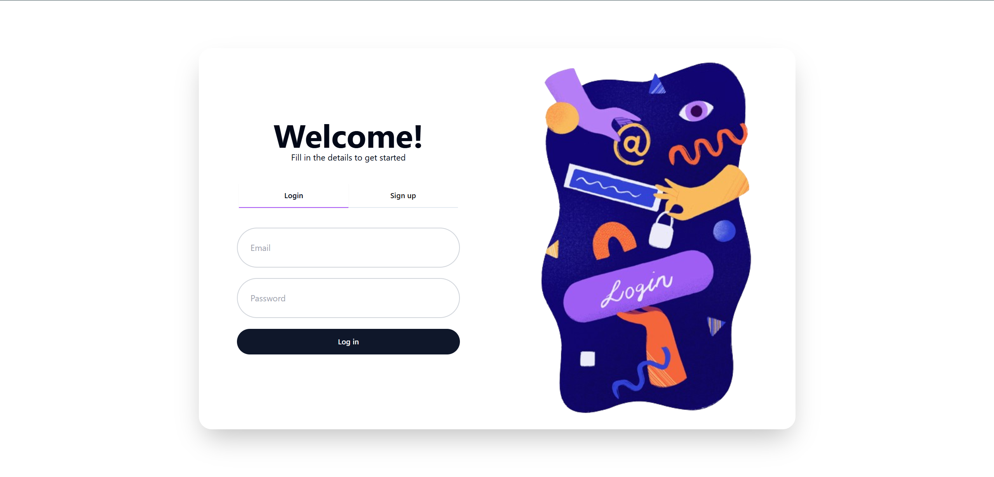

Profile Setup of User after registering:

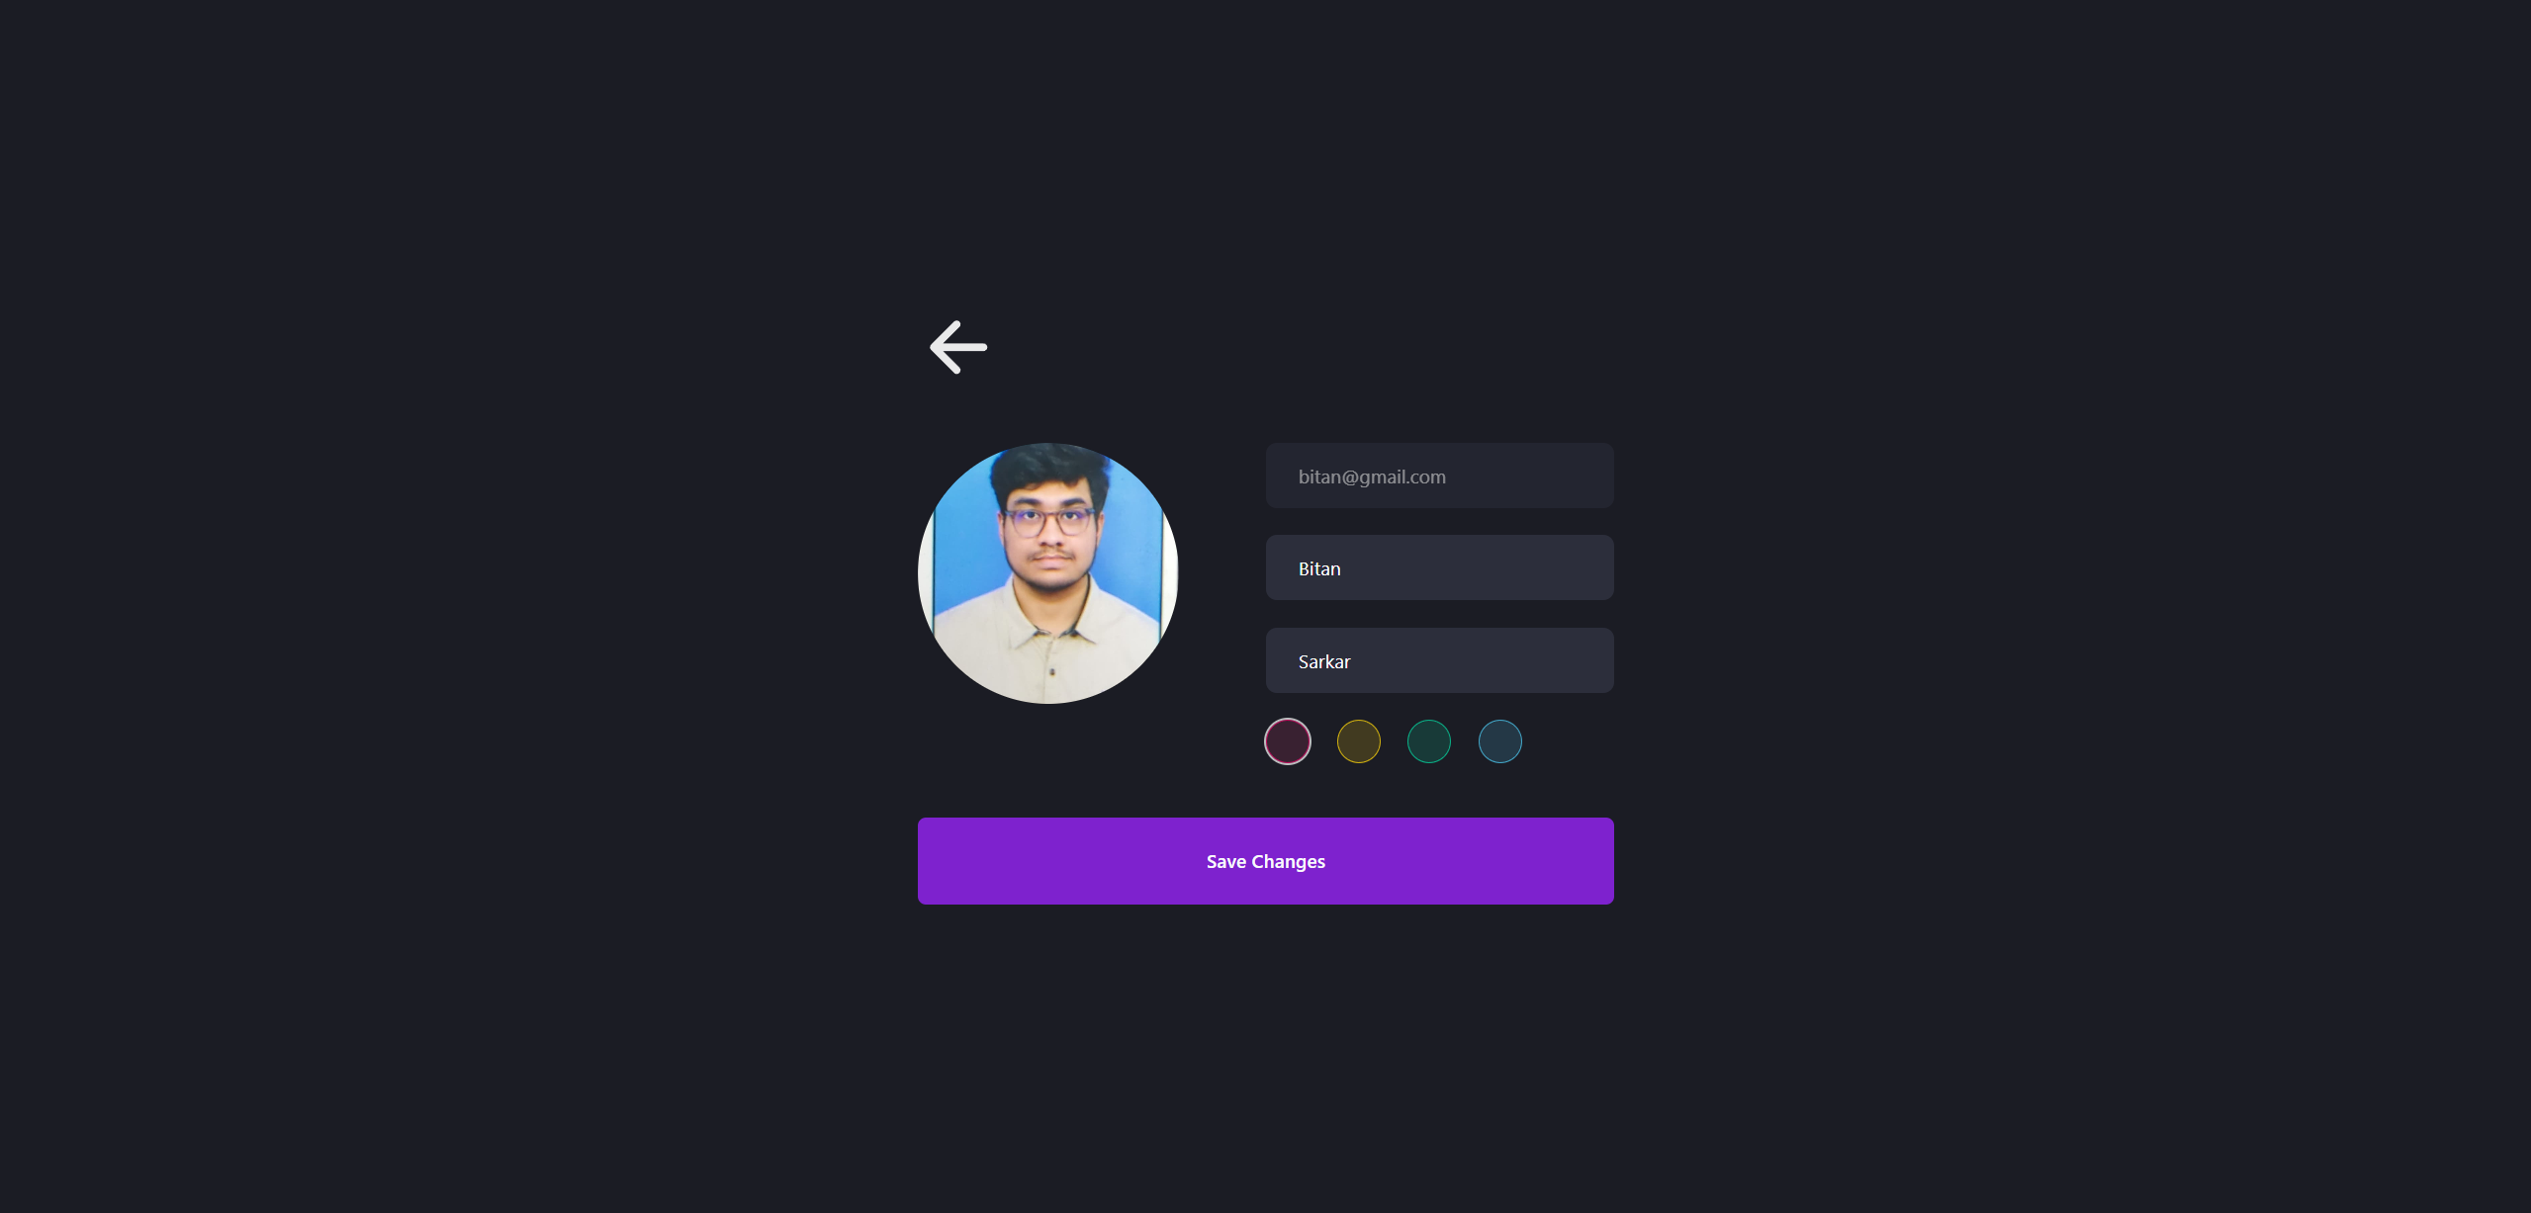
NAME OF PROJECT

Chapter 1

Introduction

In today's digital age, real-time communication has become an integral part of our daily lives. The demand for efficient and user-friendly chat applications has surged, driving the need for innovative solutions. This project aims to address this demand by developing a robust and feature-rich chat application, leveraging the power of the MERN stack: MongoDB, Express.js, React.js, and Node.js.
The MERN stack provides a comprehensive and efficient framework for building web applications. By combining the strengths of these technologies, we have created a chat application that offers a seamless user experience, real-time message delivery, and secure communication.
The project focuses on the following key features:
- User Authentication: Secure user authentication and authorization to protect user privacy and data.
- Real-time Messaging: Instantaneous message delivery and updates using WebSocket technology.
- Private Messaging: One-on-one private chat functionality for confidential conversations.
- Group Chat Rooms: Collaborative group chat rooms for discussions and teamwork.
- File Sharing: Ability to share files directly within the chat interface.
By implementing these features, the application aims to provide a versatile and engaging platform for users to connect and communicate effectively. The following sections will delve into the technical details of the project, including the system architecture, implementation details, and testing strategies.

School of Computer Engineering, KIIT, BBSR 1

NAME OF PROJECT

Chapter 2

Basic Concepts/ Literature Review

MERN Stack
The MERN stack is a popular technology stack for building modern web applications. It consists of four key technologies:
- MongoDB: A NoSQL database that stores data in a flexible, JSON-like format. It's ideal for storing user information, messages, and other dynamic data.
- Express.js: A Node.js framework for building web applications and APIs. It handles server-side logic, routing, and data processing.
- React.js: A JavaScript library for building user interfaces. It's used to create the frontend of the chat application, including the chat interface, message input, and user profiles.
- Node.js: A JavaScript runtime environment that allows you to run JavaScript on the server-side. It's used to power the backend of the application, handling requests, responses, and database interactions.
Real-time Communication
Real-time communication is essential for a chat application. It allows users to send and receive messages instantly. This is achieved using WebSocket technology. WebSocket provides a persistent connection between the client and the server, enabling bidirectional communication.
Socket.IO
Socket.IO is a JavaScript library that simplifies real-time, bidirectional communication between web clients and servers. It's used to implement features like:
- Message broadcasting: Sending messages to all connected clients.
- Private messaging: Sending messages to specific clients.
- Room-based chat: Creating and joining chat rooms.

User Authentication and Authorization
To ensure secure communication, user authentication and authorization are crucial. This involves:
- User registration: Creating new user accounts with unique usernames and passwords.
- User login: Verifying user credentials and granting access to the application.
- Session management: Maintaining user sessions to track active users and their permissions.
Data Storage
MongoDB is used to store user information, messages, and other relevant data. It provides a flexible and scalable solution for storing and retrieving data.
Frontend Development
React.js is used to build the user interface. It's a component-based framework that allows you to create reusable UI components. Key components in a chat application include:
- Chat window: Displays the chat history.
- Message input: Allows users to type and send messages.
- User list: Shows a list of online users.
- User profile: Displays user information and settings.
By combining these technologies and concepts, you can build a robust, scalable, and user-friendly chat application.

School of Computer Engineering, KIIT, BBSR 2

NAME OF PROJECT

Chapter 3

Problem Statement / Requirement Specifications

Problem Statement
The increasing demand for real-time communication has led to the need for efficient and user-friendly chat applications. Existing chat applications often lack features such as real-time message delivery, secure user authentication, and a seamless user experience. This project aims to address these shortcomings by developing a robust and feature-rich chat application using the MERN stack.

Requirement Specifications
Functional Requirements
- User Authentication and Authorization:
  - Users should be able to register and log in to the application.
  - The system should securely store user credentials.
  - Only authenticated users should be allowed to access certain features.
- Real-time Messaging:
  - Messages should be delivered to all connected users in real-time.
  - Users should be able to send and receive messages instantly.
  - The system should handle multiple concurrent connections efficiently.
- Private Messaging (direct Messaging):
  - Users should be able to send private messages to individual users.
  - Private messages should be encrypted to ensure confidentiality.
- Group Chat Rooms (Channels):
  - Users should be able to create and join group chat rooms.
  - Users should be able to send and receive messages within group chat rooms.
  - Group chat rooms should have adjustable privacy settings.
- File Sharing:
  - Users should be able to share files within chat conversations.
  - The system should support various file formats.
  - File transfers should be secure and efficient.
- User Profiles:
  - Users should be able to create and customize their profiles.
  - User profiles should display relevant information, such as username, avatar, and bio.
- User Search:
  - Users should be able to search for other users by username.
Non-Functional Requirements
- Performance:
  - The application should have low latency and high throughput.
  - The system should be able to handle a large number of concurrent users.
- Security:
  - User data should be protected from unauthorized access.
  - Sensitive information, such as passwords, should be encrypted.
  - The system should be resistant to common security threats.
- Scalability:
  - The application should be able to scale to accommodate increasing user loads.
  - The system should be easily deployable to different environments.
- Usability:
  - The user interface should be intuitive and easy to use.
  - The application should be accessible to users with different devices and screen sizes.
- Reliability:
  - The application should be highly available and reliable.
  - The system should be able to recover from failures and errors.

School of Computer Engineering, KIIT, BBSR 3

NAME OF PROJECT

Chapter 4

Implementation

Backend (Node.js and Express.js)
1. Server Setup:
- Create a Node.js server using Express.js.
- Set up middleware for handling requests, responses, and error handling.
2. Database Setup:
- Configure MongoDB to store user information, messages, and room details.
- Create schemas for users, messages, and rooms.
3. Real-time Communication:
- Implement Socket.IO to handle real-time communication.
- Create event listeners for connection, disconnection, and message events.
- Broadcast messages to all connected clients or specific rooms.
4. User Authentication and Authorization:
- Use Passport.js or a similar library to handle user authentication.
- Implement strategies for local authentication or social logins.
- Protect routes and WebSocket connections with authentication middleware.
5. API Endpoints:
- Create API endpoints for user registration, login, and profile updates.
- Implement endpoints for creating, joining, and leaving chat rooms.
- Handle file uploads and downloads.

4.3 Result Analysis OR Screenshots

HOME PAGE
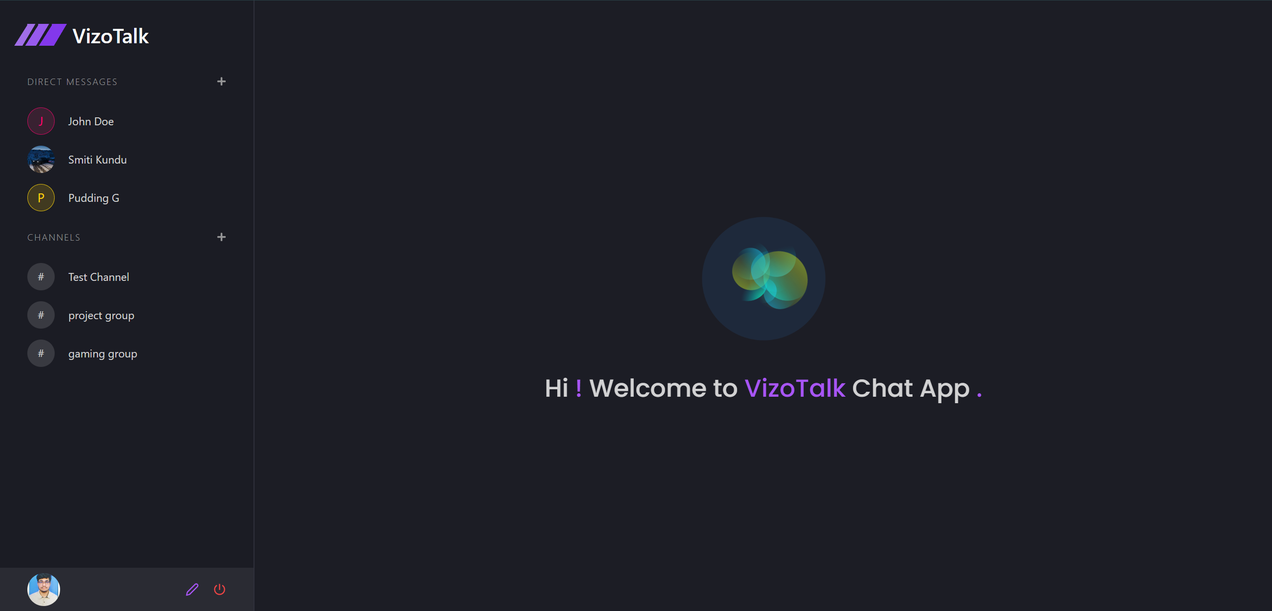

DIRECT MESSAGE (ONE TO ONE)

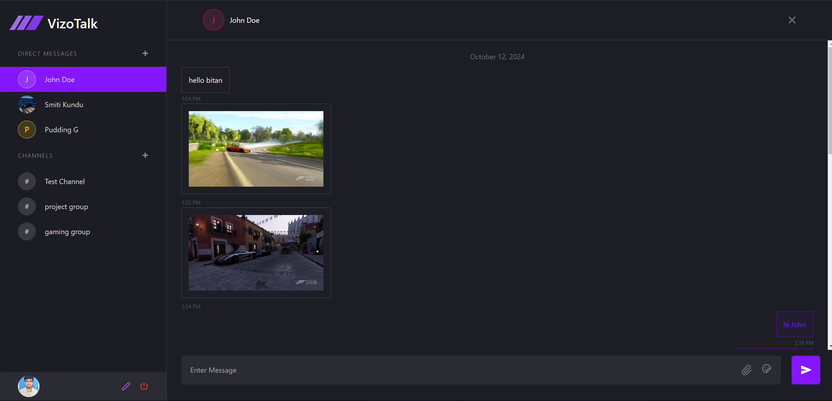

CHANNELS (GROUP CHATS)
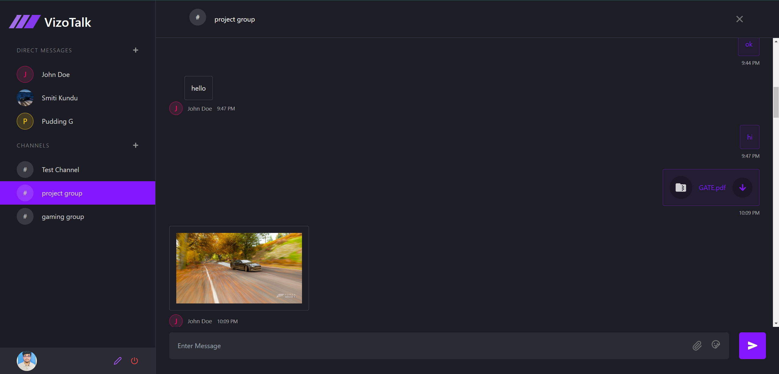

AI SUPPORT IN CHAT USING GEMINI
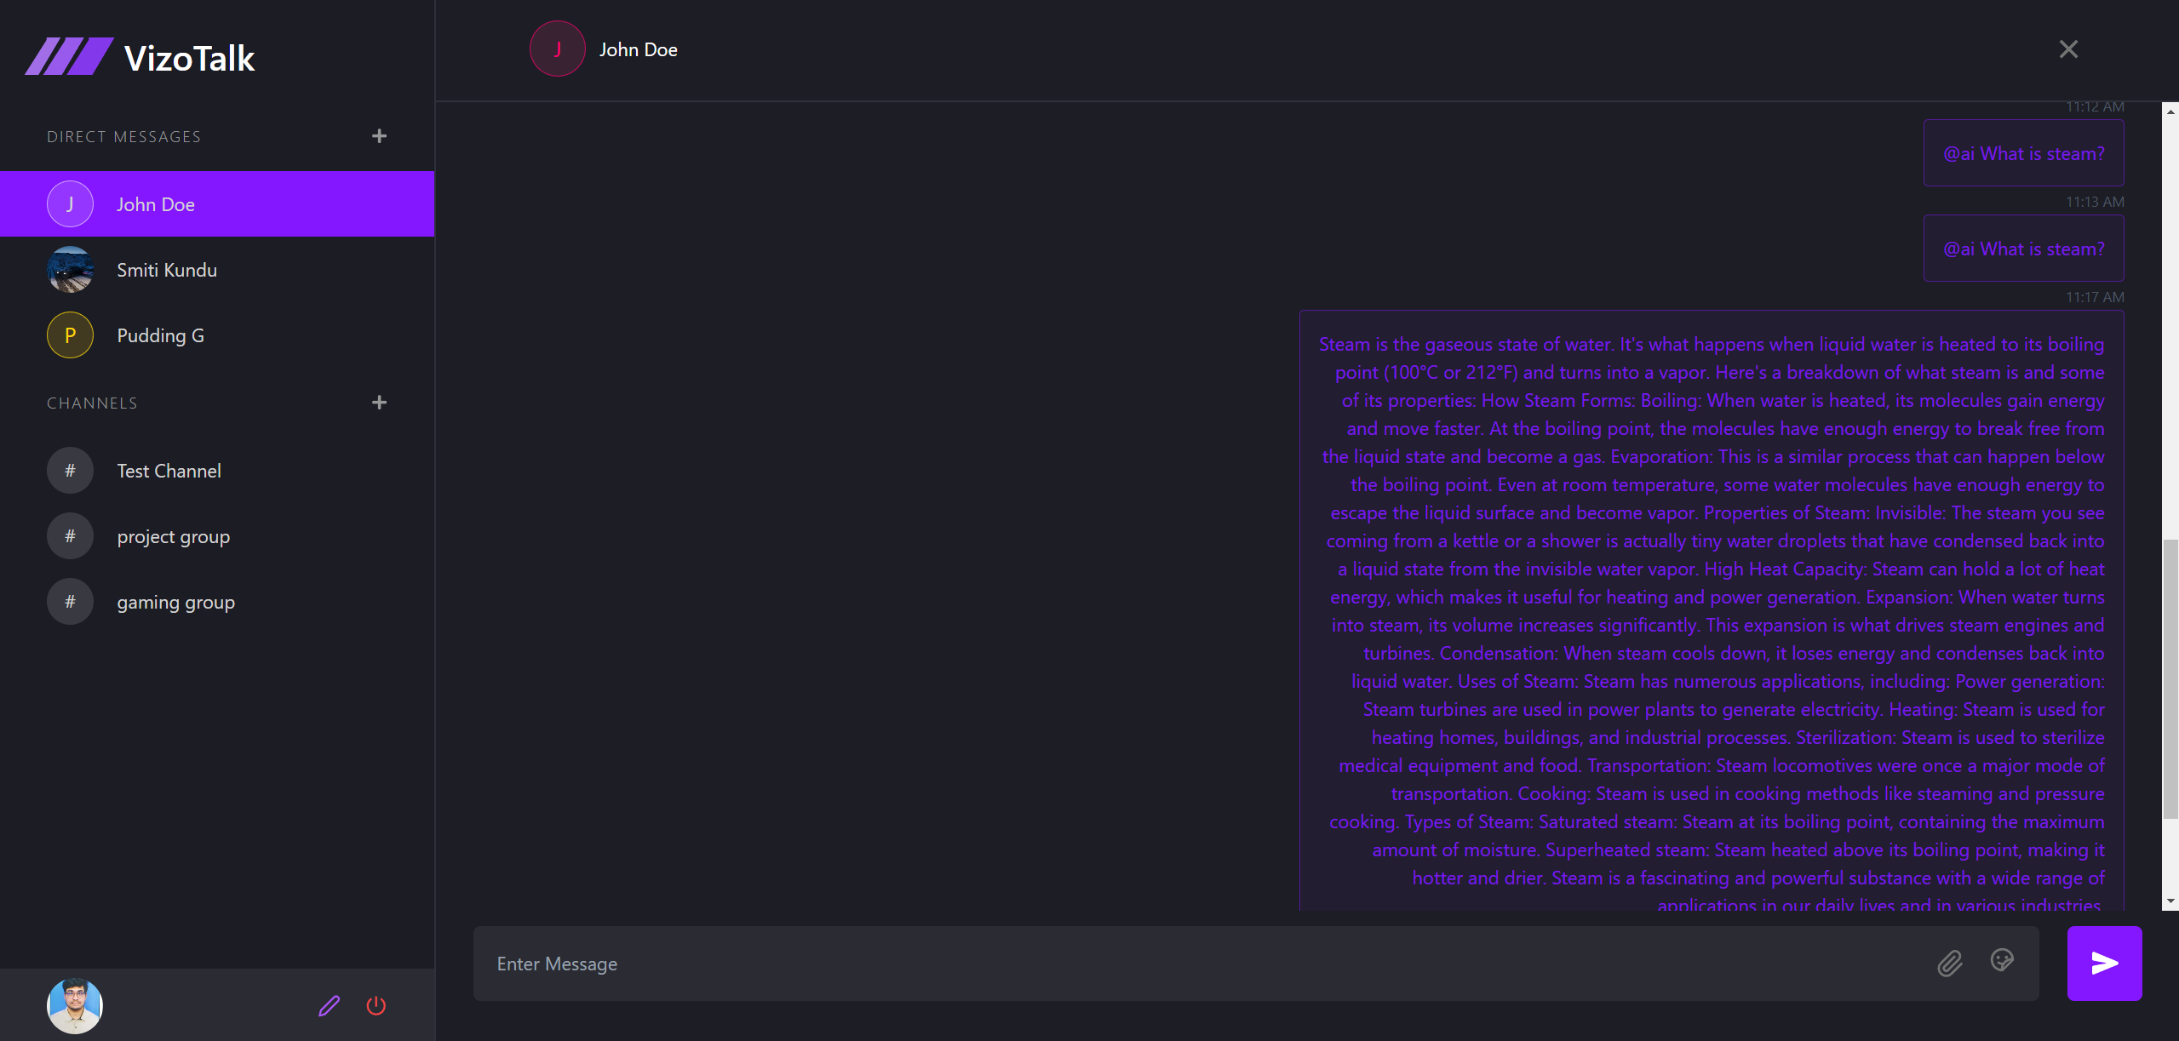

4.4 Quality Assurance

Quality Assurance (QA) is a crucial aspect of developing robust and reliable software applications. For a MERN chat application, a comprehensive QA strategy ensures a seamless user experience, optimal performance, and security.
Key QA Strategies for MERN Chat Applications
1. Unit Testing:
- Purpose: To test individual components (functions, modules) in isolation.
- Focus:
  - Correctness of calculations and data manipulation
  - Proper handling of input and output
  - Exception handling and error messages
2. Integration Testing:
- Purpose: To test how different components interact with each other.
- Focus:
  - Data flow between frontend and backend
  - API endpoint functionality
  - Database interactions
  - Real-time communication features
3. End-to-End Testing:
- Purpose: To test the entire application flow from user interaction to backend processing.
- Focus:
  - User registration and login
  - Message sending and receiving
  - File sharing
  - Group chat functionality
  - User experience and UI responsiveness
4. Performance Testing:
- Purpose: To evaluate the application's performance under load.
- Focus:
  - Response time
  - Throughput
  - Scalability
  - Resource utilization
5. Security Testing:
- Purpose: To identify and address security vulnerabilities.
- Focus:
  - Authentication and authorization mechanisms
  - Data encryption and protection
  - Cross-site scripting (XSS) and cross-site request forgery (CSRF) attacks
  - SQL injection
6. Usability Testing:
- Purpose: To evaluate the user experience and identify usability issues.
- Focus:
  - Ease of use
  - User satisfaction
  - Intuitive interface

School of Computer Engineering, KIIT, BBSR 4

NAME OF PROJECT

Chapter 5

Standards Adopted

5.1 Design Standards
When developing a MERN chat application, it's essential to adhere to industry standards and best practices to ensure quality, security, and maintainability. Here are some key standards and guidelines to consider:
Web Development Standards
- HTML5: Structure and content of web pages.
- CSS3: Styling and layout of web pages.
- JavaScript: Client-side scripting for dynamic behavior.
- ECMAScript: Standard for JavaScript.
MERN Stack-Specific Standards
- Node.js: Follows CommonJS module system and asynchronous programming paradigms.
- Express.js: Adheres to RESTful API design principles and middleware pattern.
- React.js: Follows component-based architecture and virtual DOM.
- MongoDB: Follows NoSQL data modeling principles.

5.2 Coding Standards

Clean Code Principles: Writes clean, readable, and maintainable code.
Code Style Guides: Adheres to style guides like Airbnb or Google JavaScript Style Guide.
Version Control: Uses Git for version control and collaboration.
Testing: Implements unit, integration, and end-to-end tests.
Linting: Uses tools like ESLint to enforce code style and identify potential issues.…...

School of Computer Engineering, KIIT, BBSR 5

NAME OF PROJECT

Chapter 6

Conclusion and Future Scope

6.1 Conclusion
This project successfully developed a robust and feature-rich MERN chat application. By leveraging the power of MongoDB, Express.js, React.js, and Node.js, we were able to create a real-time, scalable, and secure platform for communication. The application incorporates essential features such as user authentication, private messaging, group chat rooms, and file sharing.

The implementation of WebSocket technology enabled real-time message delivery, enhancing the user experience. The use of MongoDB provided a flexible and scalable database solution for storing user data and chat history. React.js facilitated the creation of a dynamic and responsive user interface, while Express.js and Node.js powered the backend API and real-time communication.

Through rigorous testing and quality assurance practices, we ensured the application's reliability, performance, and security. The project adhered to industry standards and best practices, resulting in a well-structured and maintainable codebase.

6.2 Future Scope

While this project has achieved significant milestones, there are several potential areas for future enhancements:

- Advanced Features:

  - Voice and Video Calling: Integrate real-time audio and video communication.

  - End-to-End Encryption: Implement end-to-end encryption for enhanced security.

- Scalability and Performance:

  - Load Balancing: Implement load balancing techniques to handle increased traffic.

  - Caching Strategies: Utilize caching mechanisms to improve response times.

  - Database Optimization: Optimize database queries and indexing for better performance.

- Integration with Other Services:

  - Third-Party Integrations: Integrate with social media platforms, cloud storage, and other services.

  - AI-Powered Features: Explore AI-powered features like sentiment analysis, automated responses, and personalized recommendations.

- Accessibility:

  - Accessibility Testing: Conduct thorough accessibility testing to ensure compliance with WCAG guidelines.

  - Screen Reader Compatibility: Optimize the application for screen readers.

By continuously exploring these areas, we can further enhance the user experience and expand the capabilities of the MERN chat application.

School of Computer Engineering, KIIT, BBSR 6

NAME OF PROJECT

References

[1 ]S. M. Metev and V. P. Veiko, Laser Assisted Microtechnology, 2nd ed., R. M. Osgood, Jr., Ed. Berlin, Germany: Springer-Verlag, 1998.

- Breckling, Ed., The Analysis of Directional Time Series: Applications to Wind Speed and Direction, ser. Lecture Notes in Statistics. Berlin, Germany: Springer, 1989, vol. 61.

- S. Zhang, C. Zhu, J. K. O. Sin, and P. K. T. Mok, “A novel ultrathin elevated channel low-temperature poly-Si TFT,” IEEE Electron Device Lett., vol. 20, pp. 569–571, Nov. 1999.

- M. Wegmuller, J. P. von der Weid, P. Oberson, and N. Gisin, “High resolution fiber distributed measurements with coherent OFDR,” in Proc. ECOC’00, 2000, paper 11.3.4, p. 109.

- R. E. Sorace, V. S. Reinhardt, and S. A. Vaughn, “High-speed digital-to-RF converter,” U.S. Patent 5 668 842, Sept. 16, 1997.

- (2002) The IEEE website. [Online]. Available: http://www.ieee.org/

[7] M. Shell. (2002) IEEEtran homepage on CTAN. [Online]. Available: http://www.ctan.org/tex-archive/macros/latex/contrib/supported/IEEEtran/

School of Computer Engineering, KIIT, BBSR 7

NAME OF PROJECT

SAMPLE INDIVIDUAL CONTRIBUTION REPORT:

<TITLE OF THE PROJECT IN FONT SIZE 14, FONT STYLE TIMES NEW ROMAN, BOLD AND CENTERED>

<Student Name (in capital letters in font size 12, Times New Roman and centered>
<Student Roll number (font size 12, Times New Roman and centered>

Abstract: A short description of the aim and objective of the project work carried out in 3-4 lines. This part should be common to all students in the group. The font size and style will remain same from this point onwards. The font size will be 12 and font style will be Times New Roman. The line spacing will be 1.5.
This report should be prepared in A4 page format with ‘default’ option under ‘Margin’ of the ‘Page Layout’ tab in Microsoft Word. Word limit for this section is 80.

Individual contribution and findings: The student should clearly indicate his/her role in the project group and the contribution in implementing the project work. The student should also outline his /her planning involved in implementing his/her part in the work. This contribution report should be different for every student in the group. The student would also write his./her technical findings and experience while implementing the corresponding part of the project. The overall contribution report should not be less than 1 page for each student. The Student should provide both the soft copy and signed hard copy to the project supervisor.

Individual contribution to project report preparation: Student should mention his/her role in preparing the group project report indicating which chapter and portions contributed.

Individual contribution for project presentation and demonstration: Student should mention his/her role in preparing presentations and part of the project demonstrated.

Full Signature of Supervisor: Full signature of the student:
……………………………. ……………………………..

School of Computer Engineering, KIIT, BBSR 8

TURNITIN PLAGIARISM REPORT
(This report is mandatory for all the projects and plagiarism
must be below 25%)

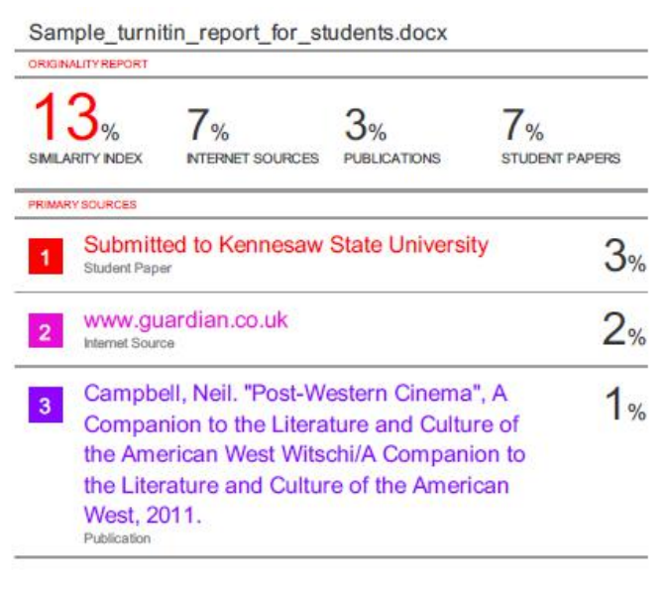

School of Computer Engineering, KIIT, BBSR 9

